**CLIENT SERVER IMPLEMENTATION USING PYTHON IN DOCKER CONTAINER**

**STEPS FOR EXECUTION:**

**Step 1:** Run the python code we get the following output

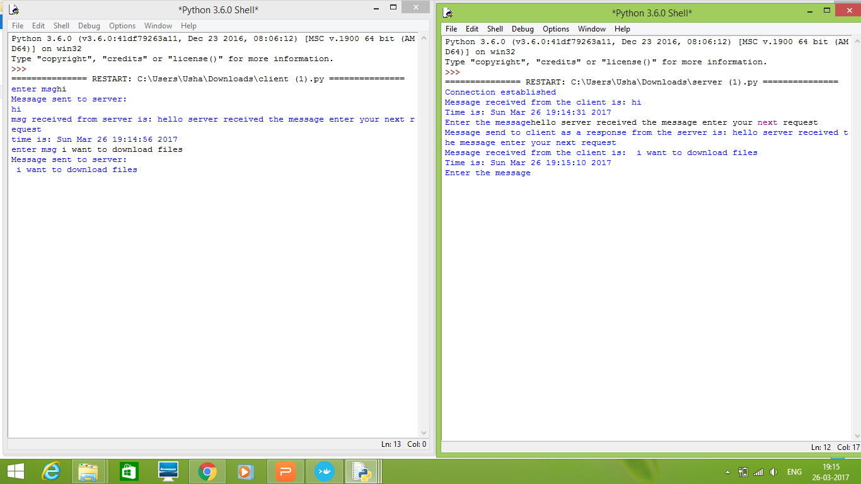

Fig . 1 .OUTPUT OF CLIENT/SERVER IN PYTHON

**Step 2** **:** Now before deploying the python code in docker pull the python image in docker terminal.

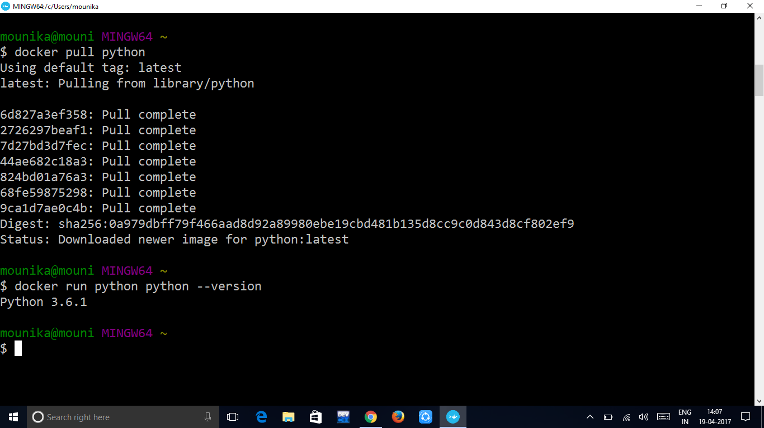

Fig .2. Pulling python image

**Step 3 :** Now we have to build images from the created docker files.We have to build client image and server image separately.

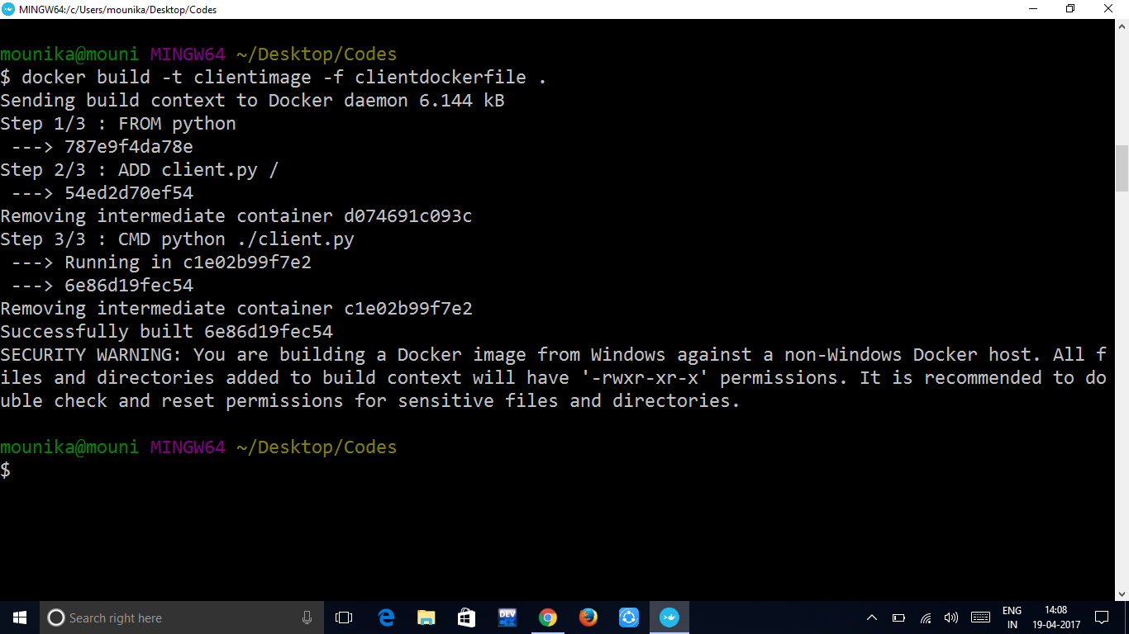

Fig .3.1 Building client image

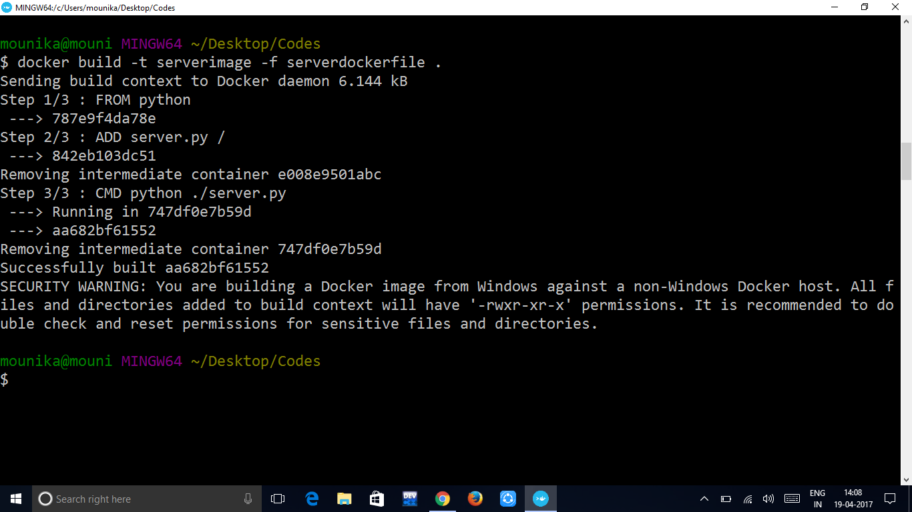

Fig .3.2 Building server image

Step 4 : Checking the whether the images are created or not .

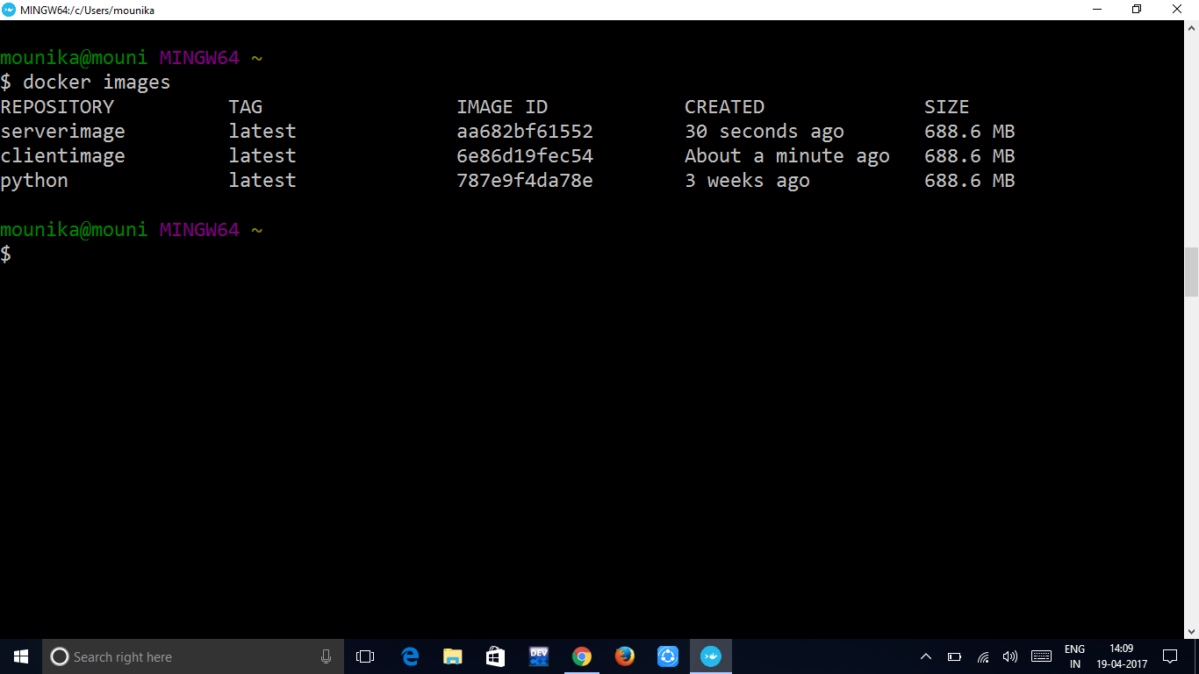

Fig. 4.Docker images

Step 5 : Running the containers

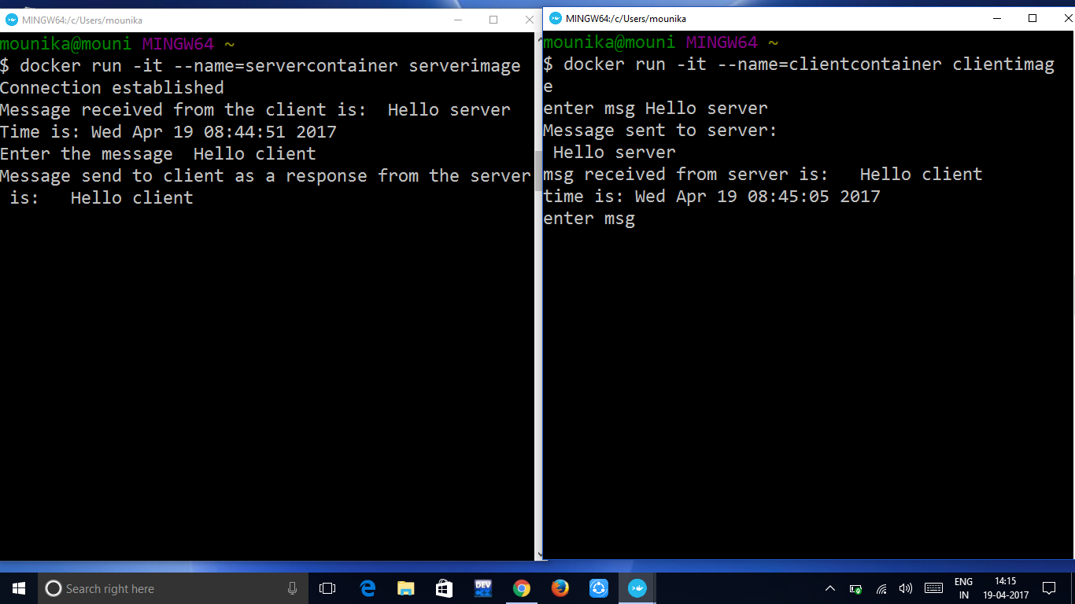

Fig.5. Running containers

Step 6 : The output is saved and the saved output is displayed using docker logs command.

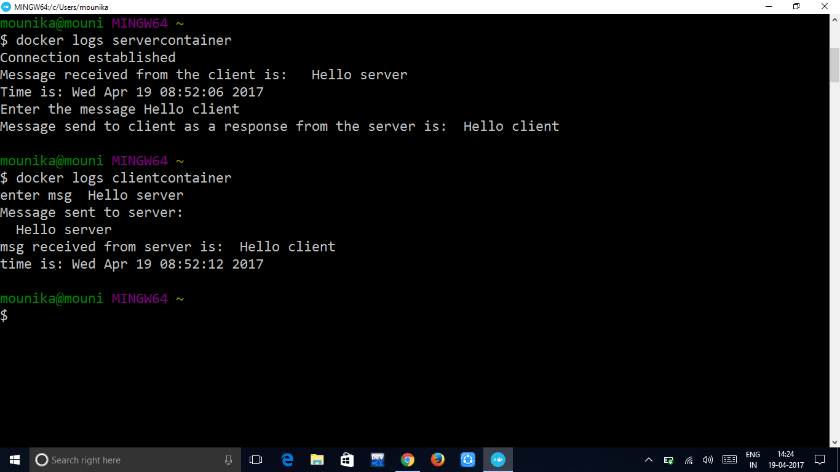

Fig .6.Docker logs